
Gilmour NASA KSC Test Plan Proposal
VERSION 1 DRAFT: B.Jessett 16/04/2022

Please make a copy of this file before editing
Add completed proposal to this folder by Thursday 21/04/2022 11:59pm

Test Plan Name: | A comparative study for lunar regolith excavation systems.
Test Plan Owner(s): | Oscar Tiger Soans-Burne, Jason Abi Chebli, Gemma Quinn
Submitted on: | 16.04.22

Hand draft sketch or CAD model(s) of test concept (if applicable)

Hardware Configuration  Configuration of rover / payload  What are you adding or changing? Mounts, test rigs etc.  What Nova Rover items | - ARC science box mounted on the rover chassis.  - Chassis suspension can be static.  - Excavation payload(s) attached to the science box.  - Hydraprobe actuator.  - Rover needs to be drivable and able to move within the RTB.
Test Objectives  What are you aiming to achieve, how does this support the team / X area of research | Objectives  This research aims to have two key benefits:  - Allow the team to contribute to global resource utilisation efforts that are relevant to the current lunar missions and build upon the research that has already been done. We can directly compare to existing lunar rovers as well as push forward the research in this area. This research can be world leading.  - Allow the team to investigate extraction methods to aid in the performance of the rover in the ARC and URC competitions.  This testing directly benefits from being done in the RTB, and cannot be accurately repeated in a sand/small scale regolith environment. This research could help with upcoming Australian lunar missions.  This test will allow for quantification and comparison of regolith extraction methods.  - If new ideas are formed within the team for regolith collection systems, they can be verified and comparatively tested.  - Off the shelf collection systems could be utilised.  - Previous URC/ARC designs made by the team can be used.  - Snoop variants can be tested.  This test could also support some investigation into dust mitigation methods such as coatings and surface preparation, as the systems are required to react with the surface.  As a team, we would need to come up with some restricting requirements for the systems. Weight, size, mounting points, power consumption (all based on our rovers capability).  Background Research  From “Parametric review…”:  - “Despite being the first step in the ISRU product chain (Fig. 2) and the foundation of any attempt to utilise lunar regolith resources effectively, relatively little research is carried out in the area of regolith excavation and almost no mature design concepts are found (Technology Readiness Level (TRL) < 4); current research mainly focuses on processing techniques.”  As detailed in “Parametric review …” we can measure performance of extraction systems with some key parameters.  However, this test allows for a direct response to the issues raised from the research. Mainly, as we are able to control the environment and rover platform, we can accurately distinguish and compare the differing methods. If we can establish use of the weight offloading system, all major issues outlined will be addressed.  Methods of excavation used in “Parametric review..” are:  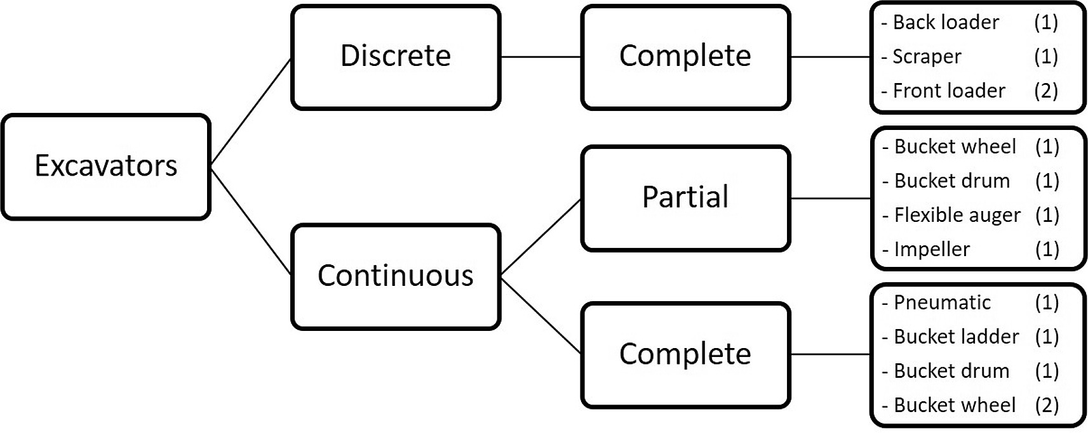  From the research outlined in “A Review of Lunar Regolith Excavation Robotic Device Prototypes”. Methods of excavation could be:  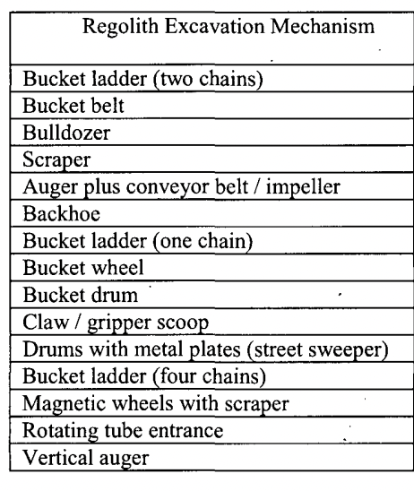
Environment  What specific environment is the system subjected to? | - Regolith test bed. The environment will become dusty from our use and excavation.  - No dust projection system.  - A tray or if available within the RTB, a mock ISRU hopper.  - Weight offloading system would be highly beneficial. (Worth enquiring again with Drew)
Methods and Primary measurement(s)  What sensors are you using (if any?)  How are you collecting data?  What | Measurements  From the “Parametric review” research, key parameters to measure are:  - Excavation rate and traverse speed  - How fast it collects regolith, (grams/minute)  - Its capacity (grams)  - Deposition rate (grams/second)  - How much it can supply to an ISRU in (grams/hour)  - Rover traversal speed  - Power consumption (W)  - Properties of simulant/analogue used  From paper, all metrics used were:  1) excavation capability, 2) depth of single cut/excavation depth (maximum reach), 3) mass of system/digging implement, 4) power/energy requirements, 5) traverse speed of the unit (i.e., rover), and 6) choice of regolith simulant/analogue used for the laboratory based testing programme  However more information is easily collected and can be used in support and to contextualise the systems in a lunar environment:  - Weight of system  - Size of system  - Amount of regolith stuck to regolith capture and collection system after deposition (g)  - Infill achieved by the bucket drum extraction system (g or percentage of volume)  - Assumes use of bucket drum excavator. Could use different excavation methods which would have corresponding specific measurements.  - Performance over time.  - How fast it collects regolith, (grams/minute)  - Its capacity (grams)  - Points of failure within regolith extraction systems due to operation/regolith.  - Forces acting on the actuation system or rover. If we can quantify the forces on the rover.  Methods of Measurement  Measurements of weights will be done by:  - Weighing systems/system trays before and after completion of testing.  - A scale underneath the ISRU hopper/plate to judge weight over time.  Measurements of power will be done by:  - Reading the current, power, voltage outputs from the CMDs or electrical components running the system. Motors/actuators.  Properties of simulant can be found from BP-1 documentation.  Photographs and video can be taken of systems in use, before/after to judge dust mitigation, mechanical performance.  Dust mitigation systems can be tested by visual inspection or weight difference. Direct a flow of air/nitrogen(if available) onto the extraction methods dust covered surface to see if material can be ejected. Can qualitatively measure dust protection methods visually.  Load cells and torque sensors can be used to quantify the forces certain excavation methods have on the ground and vice versa.  Testing Procedure (highly generalised)  - Approach marked area of the RTB - maybe 1mx1m area  - Excavate the ground  - When system is full drive to ISRU facility  - Deposit  - Repeat until X minutes have elapsed.
Mechanical requirements  In the case you are mounting items to the existing system, where will they go? How will they interface mechanically to the existing system? | - Excavation systems should mount to the ARC science box.  - Will need a variety of excavation systems that can interface with the scoop actuation system, hydraprobe mechanism or the science box in general.
Software requirements  How do the sensors interface with a PC / rover etc. what are the expected sensor outputs? UART I2C SPI etc. | - Power output of any motor running on the payload must be able to be captured by can interface and CMD publisher.  - Rover must be able to teleoperate.  - Interface to deploy excavation systems reliably.  - Upload camera footage/photographs to PC.  - Sheet to input weight and performance data matrices.
Electrical requirements  Power requirements, communications, connectors etc. Does rover already have what we need? do we need expansion? or can it all be external? | - Need to be able to supply power to differing excavation systems, whether this be motors or actuators. May need to have differing CMDs that have PID flashed for specific systems on them to enable systems to operate optimally.  - Could control some systems with twitch kits etc.
Personnel requirements  How many people are needed to undertake the testing at KSC?  What might their roles be? | - Payload expert who understands the testing, payload, context.  - Electrical and software support.
Estimated time on site to perform testing  How long will the proposed test take to undertake? Are there ways that this test could be completed in parallel with other tests? ie. test stand instead of everyone using the rover at the same time etc. | This test can be designed to be as long as wanted. The longer the more comparisons we can generate. The addition or restriction of regolith excavation systems can be used to set up how much time is spent on testing.  For each excavation system, plan for ~60mins of time for setup and test. The time for the test running will be kept constant between methods.  Number of people shouldn’t be an issue but making sure pre test checks are done will take some time - as we are doing comparisons to existing systems and research we need to be careful in our setup and method.
Supporting documents  Links to any research papers which the testing is similar to, or is based off | Testing is based around the method of the research paper.  Parametric review of existing regolith excavation techniques for lunar In Situ Resource Utilisation (ISRU) and recommendations for future excavation experiments  Methods of resource collection can be detailed from:  - A Review of Lunar Regolith Excavation Robotic Device Prototypes.pdf  - 2013 - Mueller et al. - Regolith Advanced Surface Systems Operations Robot RASSOR.pdf  All papers with this folder can be utilised for context and support:  - https://drive.google.com/drive/folders/11jkwAey39drYBJJYnzt93PHUmAC4eP_C?usp=sharing

